Question 101—Question 110
QUESTION 101

Which code fragment cause a compilation error?
- float flt = 100F;

- float flt = (float) 1_11.00;

- float flt = 100;

- double y1 = 203.22; float flt = y1;

- int y2 = 100;

float flt = (float) y2;

Answer: D

Explanation:

Exception in thread "main" java.lang.Error: Unresolved compilation problem:

Type mismatch: cannot convert from double to float

QUESTION 102

Given:
class X {

static void m (int[] i) {

i[0] += 7;

}

public static void main (String[] args) { int[] j = new int[1]; j[0] = 12;

m(j);

System.out.println(j[0]);

}

}

What is the result?

- 7

- 12

- 19

- Compilation fails.

- An exception is thrown at runtime.

Answer: C

QUESTION 103

Given:
- public class SampleClass {

- public static void main (String[] args) {

- AnotherSampleClass asc = new AnotherSampleClass();

- SampleClass sc = new SampleClass();

- // insert code here

- }

- }

- class AnotherSampleClass extends SampleClass {

- }

Which statement, when inserted into line 5, enables the code to compile?

- asc = sc;

- sc = asc;

- asc = (Object) sc;

- asc = sc.clone;

Answer: B

QUESTION 104

Which statement will empty the contents of a StringBuilder variable named sb?

- sb.deleteAll;

- sb.delete(0, sb.size());

- sb.delete(0, sb.length());

- sb.removeAll();

Answer: C

QUESTION 105

Given:

class MarksOutOfBoundsException extends IndexOutOfBoundsException { } public class GradingProcess {

void verify(int marks) throws IndexOutOfBoundsException { if (marks > 100) {

throw new MarksOutOfBoundsException(); }

if (marks > 50) {

System.out.print("Pass");

} else { System.out.print("Fail");

}

}

public static void main(String[] args) { int marks = Integer.parseInt(args[2]); try {

new GradingProcess().verify(marks);

} catch (Exception e) { System.out.print(e.getClass());

}

}

}

And the command line invocation:
java GradingProcess 89 50 104

What is the result?

- Pass

- Fail

- class MarksOutOfBoundsException

- class IndexOutOfBoundsException

- class Excpetion

Answer: C

QUESTION 106

Given:
- interface Pet { }

- class Dog implements Pet { }

- class Beagle extends Dog { }

Which three are valid?

- Pet a = new Dog();

- Pet b = new Pet();

- Dog f = new Pet();

- Dog d = new Beagle();

- Pet e = new Beagle();

- Beagle c = new Dog();

Answer: ADE

Explanation:

B and C aren’t valid because Pet is abstract and it can’t be instantiated.

F isn’t valid because a Dog isn’t a Beagle.

QUESTION 107

Given the code fragment:

StringBuilder sb = new StringBuilder(); sb.append("World");

Which fragment prints Hello World?

- sb.insert(0, "Hello "); System.out.println(sb);

- sb.append(0, "Hello "); System.out.println(sb);

- sb.add(0, "Hello "); System.out.println(sb);

- sb.set(0, "Hello "); System.out.println(sb);

Answer: A

QUESTION 108

Given:
package pkg1;

class Bb { }

public class Ee {

private Ee() { }

}

package pkg2;

final class Ww;

package pkg3;

public abstract class Dd { void m() { } }

And,
- package pkg4;

- import pkg1.*;

- import pkg2.*;

- import pkg3.*;

- // insert a class definition here

Which two class definitions, when inserted independently at line 5, enable the code to

compile?

- class Cc extends Bb { }

- class Cc extends Ww { }

- class Cc extends Ee { }

- class Cc extends Dd { }

Answer: AD

QUESTION 109

Given:
- public class Simple {

- public float price;

- public static void main (String [] args) {

- Simple price = new Simple();

- price = 4;

- }

- }

Which will make this code compile and run?

- Change line 5 to: price = 4f;

- Change line 5 to: price.price = 4;

- Change line 5 to: price = (float) 4;

- Change line 5 to: price = (Simple) 4;

- The code compiles and runs properly; no changes are necessary.

Answer: B

QUESTION 110

Given the code fragment:

Which statement is true?
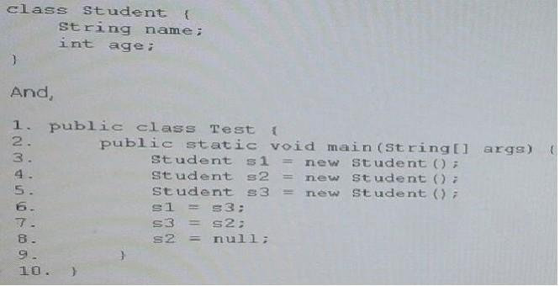

- After line 8, three objects are eligible for garbage collection.

- After line 8, two objects are eligible for garbage collection.

- After line 8, one object is eligible for garbage collection.

- After line 8, none of the objects are eligible for garbage collection.

Answer: C

Explanation:

Run the code

class Student {

String name;

int age;

- Called by the garbage collector on an object when garbage collection determines

- that there are no more references to the object.

@Override

protected void finalize () {

System.out.print("Finalized Object\n");

} }

public class Main {
public static void main(String[] args) throws

InterruptedException {

Student s1 = new Student();

Student s2 = new Student();

Student s3 = new Student();
s1 = s3;

s3 = s2;

s2 = null;
System.gc();

Thread.sleep(3000);
System.out.println(s1.name);

System.out.println(s3.name);

} }

The output is

Finalized Object

null

null
In other words,

s2 has been garbage collected.

s1 and s3 haven’t been garbage collected.

Question 111—Question 120
QUESTION 111

Given:
public class Test {

public static void main (String[] args) {

char[] arr = {97, '\t', 'e', '\n', 'i', '\t', 'o'};

for (char var: arr) {

System.out.print(var);

}

System.out.print("\nThe length is :" + arr.length);

}

}

What is the result?

- a e

The length is : 2

- a e

i o

The length is : 4

- aeio

The length is : 4

- a e

i o

The length is : 7

- Compilation fails.

Answer: D

QUESTION 112

Given the class definitrions:

class Shape { }

class Square extends Shape { }

Given the variable declarations:

Shape shape1 = null;

Square square1 = null;

Which four compile?

- shape1 = (Square) new Square();

- shape1 = new Square();

- square1 = (Square) new Shape();

- square1 = new Shape();

- square1 = new Square(); shape1 = square1;

- shape1 = new Shape(); square1 = shape1;

Answer: ABCE

QUESTION 113

Given the code fragments:

- class Student {

- int rollnumber;

- String name;

- List courses = new ArrayList();
- // insert code fragment here

- public String toString() {

- return rollnumber + " : " + name + " : " + courses;

- }

- }

And,
public class Test {

public static void main (String[] args) {

List cs = new ArrayList();

cs.add("Java");

cs.add("C");

Student s = new Student(123,"Fred",cs); System.out.println(s); }

}

Which code fragment, when inserted at line 13, enables class Test to print 123 : Fred : [Java, C] ?
- private Student(int i, String name, List cs) { /* initialization code goes here */

}

- public void Student(int i, String name, List cs) { /* initialization code goes here */

}

- Student(int i, String name, List cs) { /* initialization code goes here */

}

- Student(int i, String name, ArrayList cs) { /* initialization code goes here */

}

Answer: C

Explanation:

Incorrect: Not A: Student has private access line: Student s = new Student(123,"Fred", cs);

Not D: Cannot be applied to given types. Line: Student s = new Student(123,"Fred", cs);

QUESTION 114

Given:

What is the result?
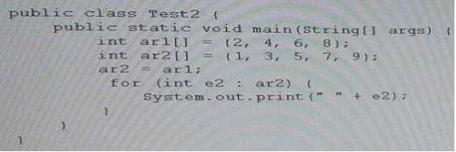

- 2 4 6 8

- 2 4 6 8 9

- 1 3 5 7

- 1 3 5 7 9

- Compilation fails

- An exception is thrown at runtime

Answer: A

QUESTION 115

Given:

What is the result?

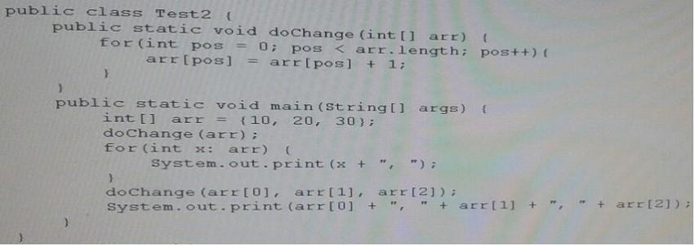

- 11, 21, 31, 11, 21, 31

- 11, 21, 31, 12, 22, 32

- 12, 22, 32, 12, 22, 32

- 10, 20, 30, 10, 20, 30

- Compilation fails

Answer: E

QUESTION 116

Which two are valid declarations of a two-dimensional array?

- int [][] array2D;

- int [2][2] array2D;

- int array2D[];

- int[] array2D[];

- int[][] array2D[];

Answer: AD

QUESTION 117

Given:
public class Natural {

private int i;

void disp() {

while (i <= 5) {

for (int i = 1; i <= 5; ) {

System.out.print(i + " ");

i++;

}

i++;

}

}

public static void main (String args[]) { new Natural().disp(); }

}
- Prints 1 2 3 4 5 once

- Prints 1 3 5 once

- Prints 1 2 3 4 5 five times

- Prints 1 2 3 4 5 six times

- Compilation fails

Answer: D

QUESTION 118

Given:
public class CheckIt {

public static void main (String[] args) {

if (doCheck()) {

System.out.print("square ");

}

System.out.print("...");

}

public static int doCheck() {

return 0;

}

}

- square ...

- ...

- Compilation fails.

- An exception is through at runtime.

Answer: C

QUESTION 119

Given:
public class Test {
}
From which class does the Java compiler implicitly derive Test?

- Object

- Class

- an anonymous class

- Objects

Answer: A

QUESTION 120

Given:
class Test {

public static void main (String[] args) {

int day = 1;

switch (day) {

case "7":

System.out.print("Uranus");

case "6":

System.out.print("Saturn");

case "1":

System.out.print("Mercury");

case "2":

System.out.print("Venus");

case "3":

System.out.print("Earth");

case "4":

System.out.print("Mars");

case "5":

System.out.print("Jupiter");

}

}

}

Which two modifications, made independently, enable the code to compile and run?

- adding a break statement after each print statement

- adding a default section within the switch code-block

- changing the string literals in each case label to integer

- changing the type of the variable day to String

- arranging the case labels in ascending order

Answer: CD

Question 121—Question 130
QUESTION 121

Given:
public class TestLoop {

public static void main(String[] args) { int array[] = {0, 1, 2, 3, 4}; int key = 3;

for (int pos = 0; pos < array.length; ++pos) { if (array[pos] == key) { break;
}
}

System.out.print("Found " + key + "at " + pos);

}

}

What is the result?

- Found 3 at 2

- Found 3 at 3

- Compilation fails

- An exception is thrown at runtime

Answer: C

Explanation:

The following line does not compile:

System.out.print("Found " + key + "at " + pos);

The variable pos is undefined at this line, as its scope is only valid in the for loop. Any variables created inside of a loop are LOCAL TO THE LOOP.

QUESTION 122

Given:
import java.util.*;

public class Ref {

public static void main(String[] args) { StringBuilder s1 = new StringBuilder("Hello Java!"); String s2 = s1.toString();

List<String> lst = new ArrayList<String>();

lst.add(s2);

System.out.println(s1.getClass());

System.out.println(s2.getClass());

System.out.println(lst.getClass());

} }

What is the result?

- class java.lang.String class java.lang.String class java.util.ArrayList

- class java.lang.Object class java.lang. Object class java.util.Collection

- class java.lang.StringBuilder class java.lang.String
class java.util.ArrayList

- class java.lang.StringBuilder class java.lang.String
class java.util.List
Answer: C

Explanation:

class java.lang.StringBuilder

class java.lang.String

class java.util.ArrayList

QUESTION 123

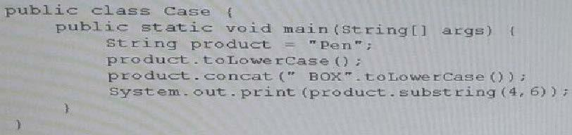
Given:

What is the result?

- box

- nbo

- bo

- nb

- An exception is thrown at runtime

Answer: E

QUESTION 124

Given:

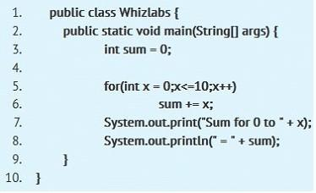

Which is true?

- Sum for 0 to 0 = 55

- Sum for 0 to 10 = 55

- Compilation fails due to error on line 6.

- Compilation fails due to error on line 7.

- An Exception is thrown at the runtime.

Answer: D

Explanation:

Loop variables scope limited to that enclosing loop. So in this case, the scope of the loop variable x declared at line 5, limited to that for loop. Trying to access that variable at line 7, which is out of scope of the variable x, causes a compile time error. So compilation fails due to error at line 7. Hence option D is correct. Options A and B are incorrect, since code fails to compile. Reference: httpsy/docs.oracle.com/javase/tutorial/java/nutsandbolts/variables.html

QUESTION 125

Given the code fragment:

What is the result?

- 28 false
29 true

- 285 < 429 true

- true
true

- compilation fails

Answer: C

QUESTION 126

Given:
public class Equal {

public static void main(String[] args) { String str1 = "Java";

String[] str2 = {"J","a","v","a"};

String str3 = "";

for (String str : str2) {

str3 = str3+str;

}

boolean b1 = (str1 == str3);

boolean b2 = (str1.equals(str3));

System.out.print(b1+", "+b2);

}
What is the result?

- true, false

- false, true

- true, true

- false, false

Answer: B

Explanation:

== strict equality.

equals compare state, not identity.

QUESTION 127

Given:
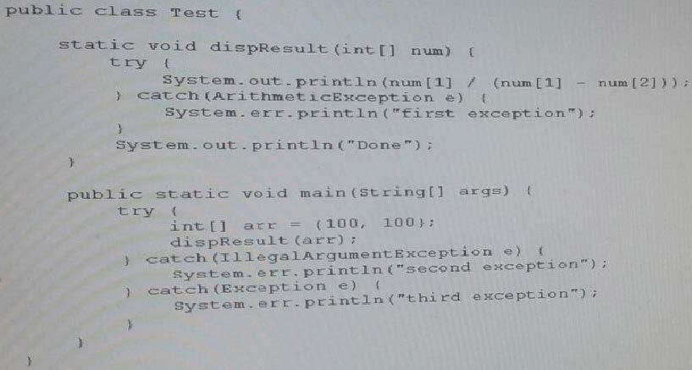

What is the result?
- 0
Done

- First Exception
Done

- Second Exception

- Done

Third Exception

- Third Exception
Answer: E

QUESTION 128

Given:
public class Marklist {

int num;

public static void graceMarks(Marklist obj4) {

obj4.num += 10;

}

public static void main(String[] args) { MarkList obj1 = new MarkList();

MarkList obj2 = obj1;

MarkList obj1 = null;

obj2.num = 60;

graceMarks(obj2);

} }
How many objects are created in the memory runtime?

- 1

- 2

- 3

- 4

Answer: A

QUESTION 129
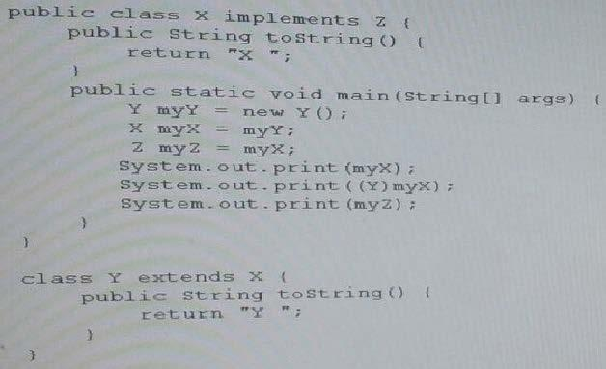
Given:

- X XX

- X Y X
- Y Y X

- Y YY

Answer: D

QUESTION 130

Given:

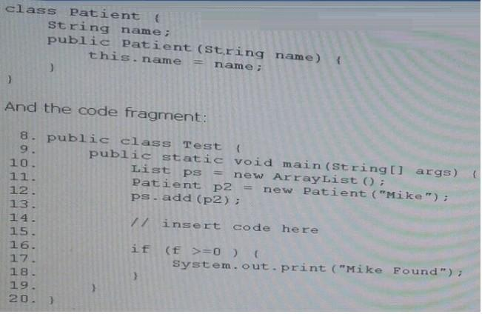

Which code fragment, when inserted at line 14, enables the code to print Mike Found?

- int f = ps.indexOf {new patient ("Mike")};

- int f = ps.indexOf (patient("Mike"));

- patient p = new Patient ("Mike"); int f = pas.indexOf(P)

- int f = ps.indexOf(p2);

Answer: D

Question 131—Question 140
QUESTION 131

Given:
public class Test {

public static void main(String[] args) { try {

String[] arr =new String[4];

arr[1] = "Unix";

arr[2] = "Linux";

arr[3] = "Solarios";

for (String var : arr) {

System.out.print(var + " ");

}

} catch(Exception e) { System.out.print (e.getClass());

}

}

}
What is the result?

- Unix Linux Solaris

- Null Unix Linux Solaris

- Class java.lang.Exception
- Class java.lang.NullPointerException

Answer: B

Explanation:

null Unix Linux Solarios

The first element, arr[0], has not been defined.

QUESTION 132

Given:
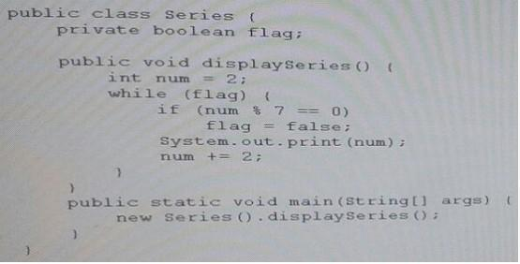

What is the result?

- 2 4 6 8 10 12

- 2 4 6 8 10 12 14

- Compilation fails

- The program prints multiple of 2 infinite times

- The program prints nothing

Answer: E

QUESTION 133

Which of the following can fill in the blank in this code to make it compile?
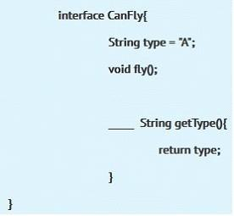

- abstract

- public

- default

- It will not compile with any as interfaces cannot have non abstract methods.

- It will compile without filling the blank.

Answer: C

Explanation:

From Java SE 8, we can use static and/or default methods in interfaces, but they should be non abstract methods.

SO in this case using default in blank is completely legal.

Hence option C is correct.

Option A is incorrect as given method is not abstract, so can't use abstract there.

Options B and E are incorrect as we can't have non abstract method interface if they are not

default or static.

https;//docs.oraclexom/javase/tutorial/java/Iandl/defaultmethods.html

QUESTION 134

Consider following method
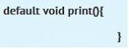

Which statement is true?

- This method is invalid.

- This method can be used only in an interface.

- This method can return anything.

- This method can be used only in an interface or an abstract class.

- None of above.

Answer: B

Explanation:

Given method is declared as default method so we can use it only inside an interface.

Hence option B is correct and option D is incorrect.

Option A is incorrect as it is valid method.

Option C is incorrect as return type is void, which means we can't return anything.

QUESTION 135

Given:
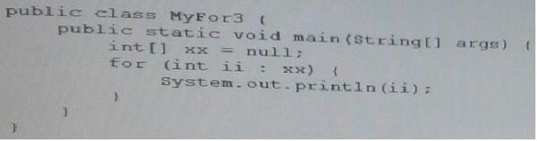

What is the result?

- Null

- Compilation fails

- An exception is thrown at runtime

- 0

Answer: C

QUESTION 136
Given:
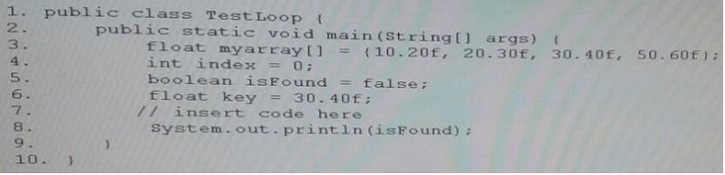

Which code fragment, when inserted at line 7, enables the code print true?
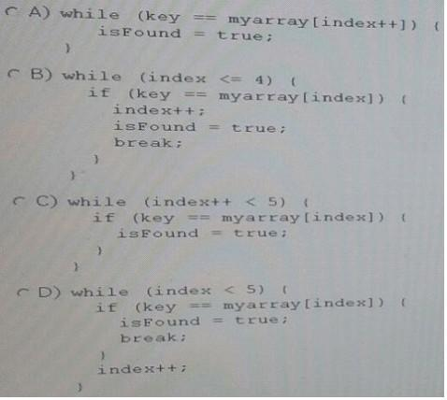

- Option A

- Option B

- Option C

- Option D

Answer: D

QUESTION 137

Given:
class Base {

public static void main(String[] args) { System.out.println("Base " + args[2]); }

}

public class Sub extends Base{

public static void main(String[] args) { System.out.println("Overriden " + args[1]); }

}

And the commands:

javac Sub.java

java Sub 10 20 30

What is the result?

- Base 30

- Overridden 20

- Overridden 20 Base 30

- Base 30 Overridden 20
Answer: B

QUESTION 138

Given:
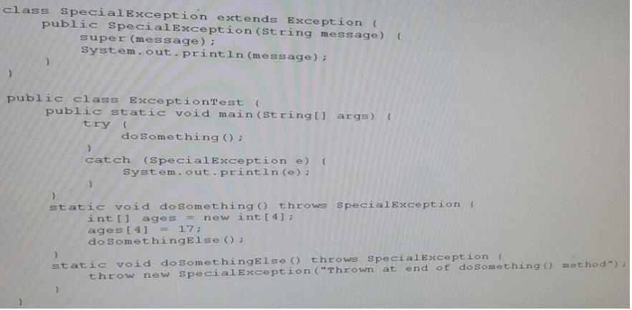

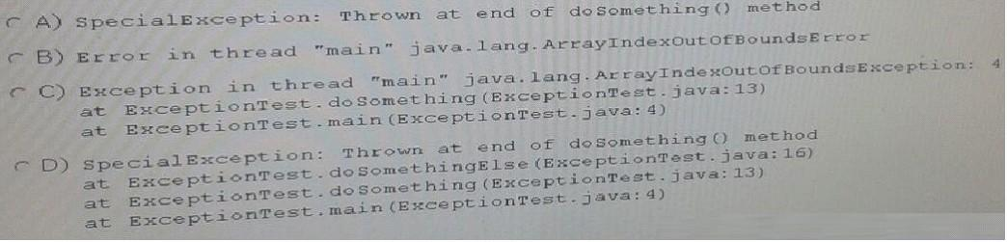
What will be the output?

- Option A

- Option B

- Option C

- Option D

Answer: C

QUESTION 139

Given the code fragments:
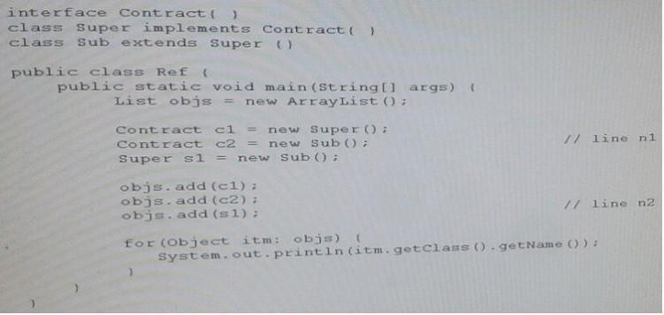

What is the result?
- Super
Sub
Sub

- Contract
Contract
Super

- Compilation fails at line n1

- Compilation fails at line n2

Answer: A
QUESTION 140

Given:
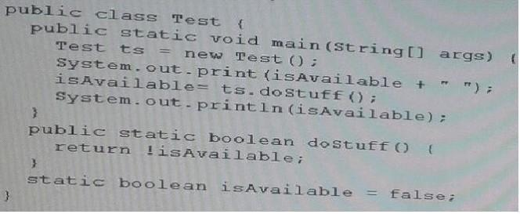

What is the result?

- true true

- true false

- false true

- false false

- Compilation fails

Answer: C

